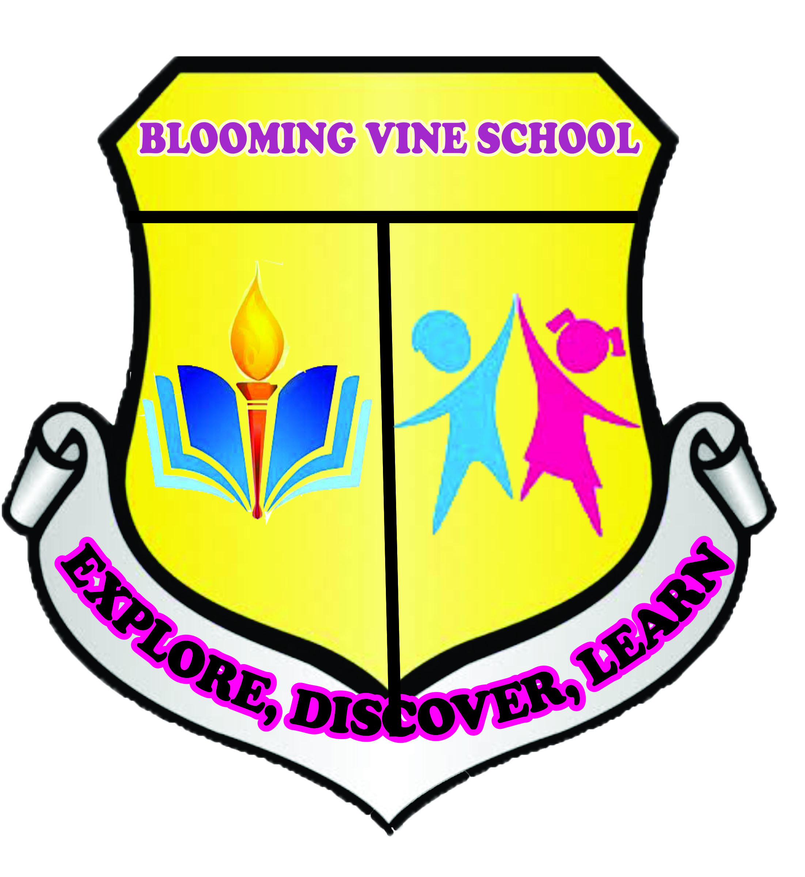
BLOOMING VINE SCHOOL
2023/2024 SESSION
2ND TERM EXAMINATION
NAME: ______________________________
SUBJECT: PHONICS
CLASS: NURSERY 1
Sound and write these two letter words
ab = ____________________
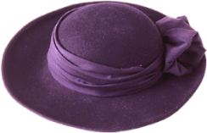
af = ____________________
ah = ____________________
aj = ____________________
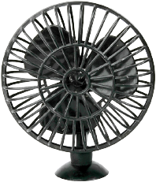
ma ____________________
Match the following sounds to their objects
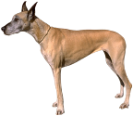
a


b

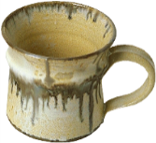
c

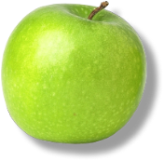
d

Write the first two sounds of each sound
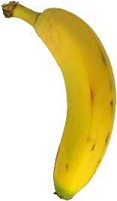

=

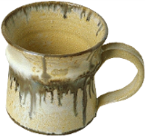

=

=
=

=

BLOOMING VINE SCHOOL
2023/2024 SESSION
2ND TERM EXAMINATION
NAME: ______________________________
CLASS: NURSERY 1
SUBJECT: C.R.K
1. Who is God? (a) daddy and mummy (b) Heavenly father (c) sister and brother
2. Mention 2 things created by God
i. ________________________________
ii. _______________________________
3. Who were our first parents? (a) Adam and Eve (b) Joseph and Mary (c) Mummy and daddy
4. Do you love father Abraham? (a) yes (b) No
5. Say the rhyme on Father Abraham
6. Did God create us? (a) Yes (b) No
7. Do you love God? (a) Yes (b) No
8. ____created our first parents (a) Daddy (b) God
9. Human beings were created by ____ (a) mummy (b) God
10. Are you one of father Abraham’s children? (a) yes (b) No

SUBJECT: LETTER WORK CLASS: NURSERY I
1. Read orally - A- Q
2. Identify these letters:
A B C D E F G H I J K L M N O P Q
3. Trace these letters

4. Read and rewrite these letters
A | B | C | D | E | F
5. Read and write A– Q
________ ___________ __________
________ ___________ __________
________ ___________ __________
________ ___________ __________
________ ___________ __________
________ ___________

BLOOMING VINE SCHOOL
2023/2024 SESSION
2ND TERM EXAMINATION
NAME: ______________________________
CLASS: NURSERY 1
SUBJECT: PRE-SCIENCE
1. What type of food are these

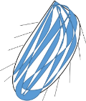
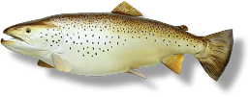

2. Mention the uses of water
i. _____________________________
ii. ______________________________
iii.______________________________
iv. ______________________________
3. Do we have 2 types of water?
(a) yes (b) No

4. Mention 2 types of water
i. ________________________________
ii. _______________________________
5. Is it good to drink dirty water
(a) yes (b) No
6. Mention 3 sources of water
i. ________________________________
ii. _______________________________
iii. ______________________________
7. Mention 2 types of flower
i. ________________________________
ii. ________________________________
8. Are tulip flower and daisy flowers types of flower (a) yes (b) No
9. Mention these parts of the body
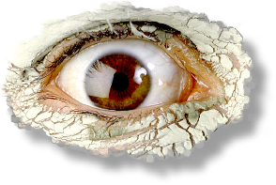

10. What do you use your eyes to do?
_______________________________

BLOOMING VINE SCHOOL
2023/2024 SESSION
2ND TERM EXAMINATION
NAME: ______________________________
SUBJECT: CREATIVE ART
CLASS: NURSERY 1
1. Colour this letter

2. Draw this pattern
c | c | c | c

3. Colour letter G for goat

4. Colour this object

5. Draw this pattern work

BLOOMING VINE SCHOOL
2023/2024 SESSION
2ND TERM EXAMINATION
NAME: ______________________________
CLASS: NURSERY 1
SUBJECT: HEALTH EDUCATION
1. Is it good to play with sand? (a) yes (b) No
2. Is it good to play with sharp object? (a) yes (b) No
3. Mention these sharp objects
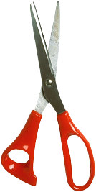
_______________

______________

4. Is it good to cut your finger nails short? (a) Yes (b) No
5. Is it good to wash your hands all the time? (a) Yes (b)No
6. Is it good to care for our hand? (a) yes (b) No
7. Is it good to pick something from the floor and eat? (a) yes (b) No
8. Is it good to do physical exercise? (a) Yes (b) No
9. Is it good to wash your fruits before eating them? (a) yes (b) No

10. Mention these fruits
